Chapter 10 Problems

1, 2, 3 = straightforward, intermediate, challenging

Section 10.1 Angular Position, Velocity, and Acceleration

1. During a certain period of time, the angular position of a swinging door is described by = 5.00 + 10.0t + 2.00t², where is in radians and t is in seconds. Determine the angular position, angular speed, and angular acceleration of the door (a) at t = 0 and (b) at t = 3.00 s.

Section 10.2 Rotational Kinematics: Rotational Motion with Constant Angular Acceleration

2. A dentist's drill starts from rest. After 3.20 s of constant angular acceleration, it turns at a rate of 2.51 × 10⁴ rev/min. (a) Find the drill's angular acceleration. (b) Determine the angle (in radians) through which the drill rotates during this period.

3. A wheel starts from rest and rotates with constant angular acceleration to reach an angular speed of 12.0 rad/s in 3.00 s. Find (a) the magnitude of the angular acceleration of the wheel and (b) the angle in radians through which it rotates in this time.

4. An airliner arrives at the terminal, and the engines are shut off. The rotor of one of the engines has an initial clockwise angular speed of 2 000 rad/s. The engine's rotation slows with an angular acceleration of magnitude 80.0 rad/s². (a) Determine the angular speed after 10.0 s. (b) How long does it take the rotor to come to rest?

5. An electric motor rotating a grinding wheel at 100 rev/min is switched off. With constant negative angular acceleration of magnitude 2.00 rad/s², (a) how long does it take the wheel to stop? (b) Through how many radians does it turn while it is slowing down?

6. A centrifuge in a medical laboratory rotates at an angular speed of 3 600 rev/min. When switched off, it rotates 50.0 times before coming to rest. Find the constant angular acceleration of the centrifuge.

7. The tub of a washer goes into its spin cycle, starting from rest and gaining angular speed steadily for 8.00 s, at which time it is turning at 5.00 rev/s. At this point the person doing the laundry opens the lid, and a safety switch turns off the washer. The tub smoothly slows to rest in 12.0 s. Through how many revolutions does the tub turn while it is in motion?

8. A rotating wheel requires 3.00 s to rotate through 37.0 revolutions. Its angular speed at the end of the 3.00-s interval is
98.0 rad/s. What is the constant angular acceleration of the wheel?

9. (a) Find the angular speed of the Earth’s rotation on its axis. As the Earth turns toward the east, we see the sky turning toward the west at this same rate.

(b) The rainy Pleiads wester
And seek beyond the sea
The head that I shall dream of
That shall not dream of me.
–A. E. Housman (© Robert E. Symons)

Cambridge, England, is at longitude 0° and Saskatoon, Saskatchewan, is at longitude 107°west. How much time elapses after the Pleiades set in Cambridge until these stars fall below the western horizon in Saskatoon?

10. A merry-go-round is stationary. A dog is running on the ground just outside its circumference, moving with a constant angular speed of 0.750 rad/s. The dog does not change his pace when he sees what he has been looking for: a bone resting on the edge of the merry-go-round one-third of a revolution in front of him. At the instant the dog sees the bone (t = 0), the merry-go-round begins to move in the direction the dog is running, with a constant angular acceleration of 0.015 0 rad/s². (a) At what time will the dog reach the bone? (b) The confused dog keeps running and passes the bone. How long after the merry-go-round starts to turn do the dog and the bone draw even with each other for the second time?

Section 10.3 Angular and Linear Quantities

11. Make an order-of-magnitude estimate of the number of revolutions through which a typical automobile tire turns in 1 yr. State the quantities you measure or estimate and their values.

12. A racing car travels on a circular track of radius 250 m. If the car moves with a constant linear speed of 45.0 m/s, find (a) its angular speed and (b) the magnitude and direction of its acceleration.

13. A wheel 2.00 m in diameter lies in a vertical plane and rotates with a constant angular acceleration of 4.00 rad/s². The wheel starts at rest at t = 0, and the radius vector of a certain point P on the rim makes an angle of 57.3° with the horizontal at this time. At t = 2.00 s, find (a) the angular speed of the wheel, (b) the tangential speed and the total acceleration of the point P, and (c) the angular position of the point P.

14. Figure P10.14 shows the drive train of a bicycle whose wheels are 67.3 cm in diameter and having pedal cranks that are 17.5 cm long. The cyclist pedals at a steady angular rate of 76.0 rev/min. The chain engages with a front sprocket 15.2 cm in diameter and a rear sprocket 7.00 cm in diameter. (a) Calculate the speed of a link of the chain relative to the bicycle frame. (b) Calculate the angular speed of the bicycle wheels. (c) Calculate the speed of the bicycle relative to the road. (d) What pieces of data, if any, are not necessary for the calculations?

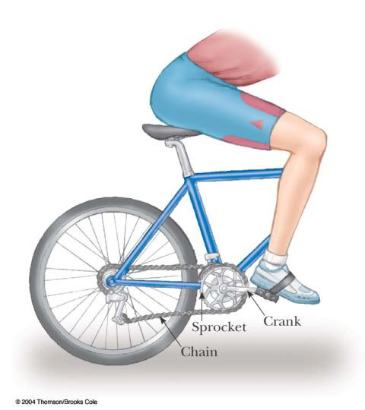

Figure P10.14

15. A discus thrower accelerates a discus from rest to a speed of 25.0 m/s by whirling it through 1.25 rev. Assume the discus moves on the arc of a circle 1.00 m in radius. (a) Calculate the final angular speed of the discus. (b) Determine the magnitude of the angular acceleration of the discus, assuming it to be constant. (c) Calculate the time interval required for the discus to accelerate from rest to 25.0 m/s.

16. A car accelerates uniformly from rest and reaches a speed of 22.0 m/s in 9.00 s. If the diameter of a tire is 58.0 cm, find (a) the number of revolutions the tire makes during this motion, assuming that no slipping occurs. (b) What is the final angular speed of a tire in revolutions per second?

17. A disk 8.00 cm in radius rotates at a constant rate of 1 200 rev/min about its central axis. Determine (a) its angular speed, (b) the tangential speed at a point 3.00 cm from its center, (c) the radial acceleration of a point on the rim, and (d) the total distance a point on the rim moves in 2.00 s.

18. A car traveling on a flat (unbanked) circular track accelerates uniformly from rest with a tangential acceleration of
1.70 m/s². The car makes it one-quarter of the way around the circle before it skids off the track. Determine the coefficient of static friction between the car and track from these data.

19. Consider a tall building located on the Earth’s equator. As the Earth rotates, a person on the top floor of the building moves faster than someone on the ground with respect to an inertial reference frame, because the latter person is closer to the Earth’s axis. Consequently, if an object is dropped from the top floor to the ground a distance h below, it lands east of the point vertically below where it was dropped. (a) How far to the east will the object land? Express your answer in terms of h, g and the angular speed ω of the Earth. Neglect air resistance, and assume that the free-fall acceleration is constant over this range of heights. (b) Evaluate the eastward displacement for h = 50.0 m. (c) In your judgment, were we justified in ignoring this aspect of the Coriolis effect in our previous study of free fall?

Section 10.4 Rotational Kinetic Energy

20. Rigid rods of negligible mass lying along the y axis connect three particles (Fig. P10.20). If the system rotates about the x axis with an angular speed of 2.00 rad/s, find (a) the moment of inertia about the x axis and the total rotational kinetic energy evaluated from 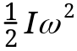 and (b) the tangential speed of each particle and the total kinetic energy evaluated from
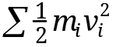.

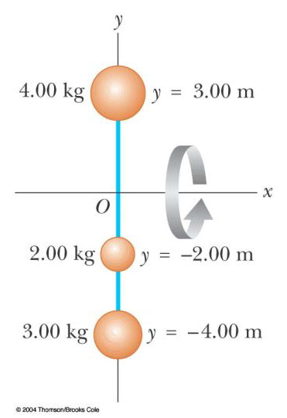

Figure P10.20

21. The four particles in Figure P10.21 are connected by rigid rods of negligible mass. The origin is at the center of the rectangle. If the system rotates in the xy plane about the z axis with an angular speed of 6.00 rad/s, calculate (a) the moment of inertia of the system about the z axis and (b) the rotational kinetic energy of the system.

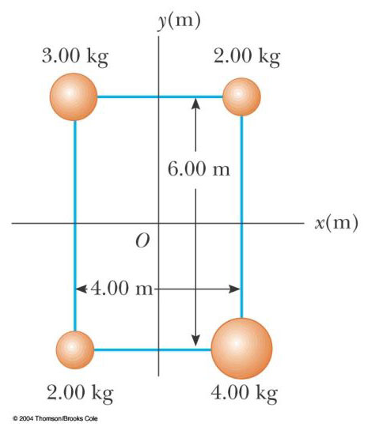

Figure P10.21

22. Two balls with masses M and m are connected by a rigid rod of length L and negligible mass as in Figure P10.22. For an axis perpendicular to the rod, show that the system has the minimum moment of inertia when the axis passes through the center of mass. Show that this moment of inertia is
I = L², where = mM/(m + M).

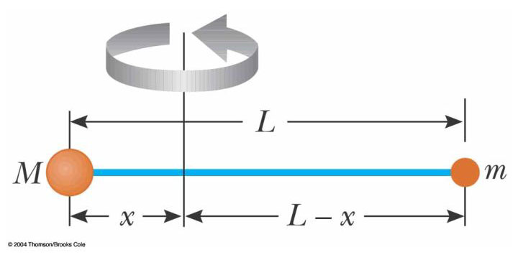

Figure P10.22

Section 10.5 Calculation of Moments of Inertia

23. Three identical thin rods, each of length L and mass m, are welded perpendicular to one another as shown in Figure P10.23. The assembly is rotated about an axis that passes through the end of one rod and is parallel to another. Determine the moment of inertia of this structure.

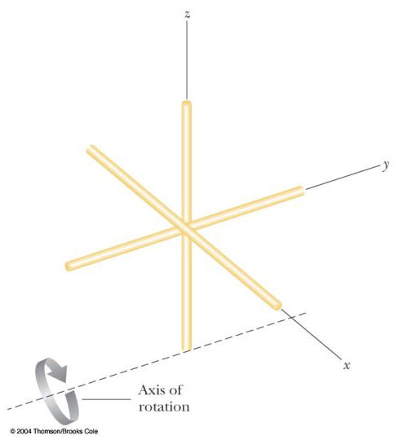

Figure P10.23

24. Figure P10.24 shows a side view of a car tire. Model it as having two sidewalls of uniform thickness 0.635 cm and a tread wall of uniform thickness 2.50 cm and width 20.0 cm. Assume the rubber has uniform density 1.10 × 10³ kg/m³. Find its moment of inertia about an axis through its center.

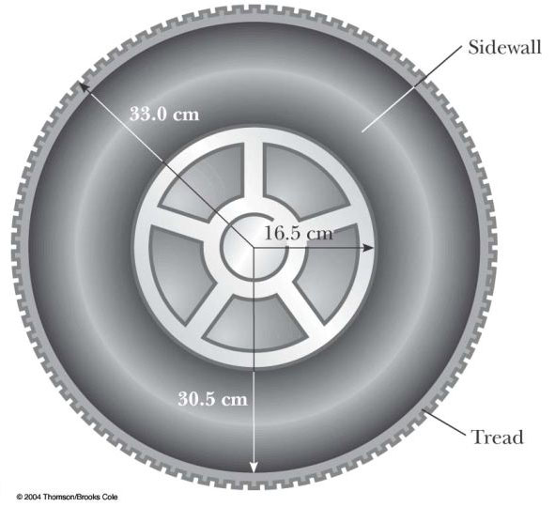

Figure P10.24

25. A uniform thin solid door has height 2.20 m, width 0.870 m, and mass 23.0 kg. Find its moment of inertia for rotation on its hinges. Is any piece of data unnecessary?

26. Attention! About face! Compute an order-of-magnitude estimate for the moment of inertia of your body as you stand tall and turn about a vertical axis through the top of your head and the point half way between your ankles. In your solution state the quantities you measure or estimate and their values.

27. The density of the Earth, at any distance r from its center, is approximately

 = [14.2 – 11.6 r/R] × 10³ kg/m³

where R is the radius of the Earth. Show that this density leads to a moment of inertia I = 0.330MR² about an axis through the center, where M is the mass of the Earth.

28. Calculate the moment of inertia of a thin plate in the shape of a right triangle, about an axis that passes through one end of the hypotenuse and is parallel to the opposite leg of the triangle, as in Figure P10.28a. Let M represent the mass of the triangle and L the length of the base of the triangle perpendicular to the axis of rotation. Let h represent the height of the triangle and w the thickness of the plate, much smaller than L or h. Do the calculation in either or both of the following ways, as your instructor assigns:
(a) Use Equation 10.17. Let an element of mass consist of a vertical ribbon within the triangle, of width dx, height y, and thickness w. With x representing the location of the ribbon, show that y = hx/L. Show that the density of the material is given by = 2M/Lwh. Show that the mass of the ribbon is dm = yw dx = 2Mx dx/L². Proceed to use Equation 10.17 to calculate the moment of inertia.
(b) Let I represent the unknown moment of inertia about an axis through the corner of the triangle. Note that Example 9.15 demonstrates that the center of mass of the triangle is two-thirds of the way along the length L, from the corner toward the side of height h. Let I_{CM} represent the moment of inertia of the triangle about an axis through the center of mass and parallel to side h. Demonstrate that I = I_{CM} + 4ML²/9. Figure P10.28b shows the same object in a different orientation. Demonstrate that the moment of inertia of the triangular plate, about the y axis is I_{h} = I_{CM} + ML²/9. Demonstrate that the sum of the moments of inertia of the triangles shown in parts (a) and (b) of the figure must be the moment of inertia of a rectangular sheet of mass 2M and length L, rotating like a door about an axis along its edge of height h. Use information in Table 10.2 to write down the moment of inertia of the rectangle, and set it equal to the sum of the moments of inertia of the two triangles. Solve the equation to find the moment of inertia of a triangle about an axis through its center of mass, in terms of M and L. Proceed to find the original unknown I.

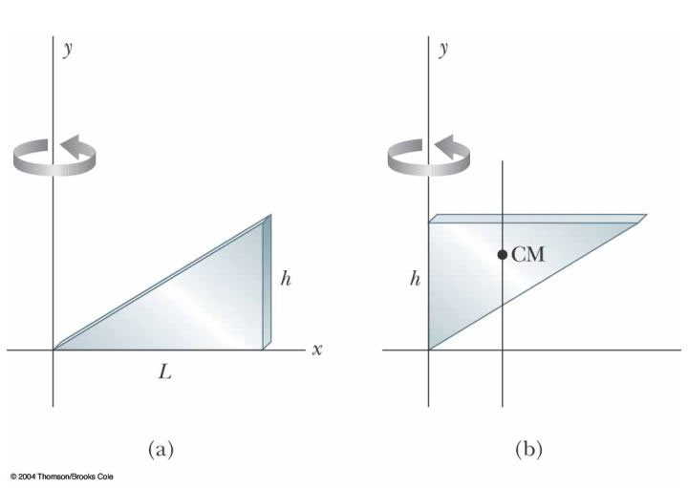

Figure P10.28

29. Many machines employ cams for various purposes, such as opening and closing valves. In Figure P10.29, the cam is a circular disk rotating on a shaft that does not pass through the center of the disk. In the manufacture of the cam, a uniform solid cylinder of radius R is first machined. Then an off-center hole of radius R/2 is drilled, parallel to the axis of the cylinder, and centered at a point a distance R/2 from the center of the cylinder. The cam, of mass M, is then slipped onto the circular shaft and welded into place. What is the kinetic energy of the cam when it is rotating with angular speed about the axis of the shaft?

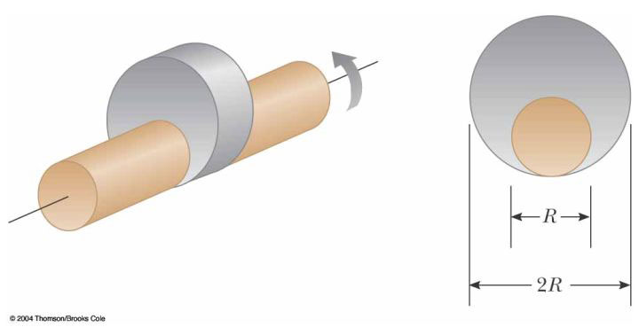

Figure P10.29

Section 10.6 Torque

30. The fishing pole in Figure P10.30 makes an angle of 20.0° with the horizontal. What is the torque exerted by the fish about an axis perpendicular to the page and passing through the fisher's hand?

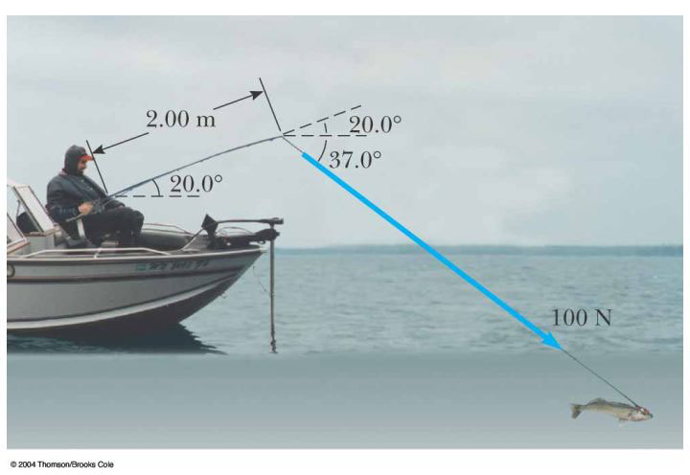

Figure P10.30

31. Find the net torque on the wheel in Figure P10.31 about the axle through O if a = 10.0 cm and b = 25.0 cm.

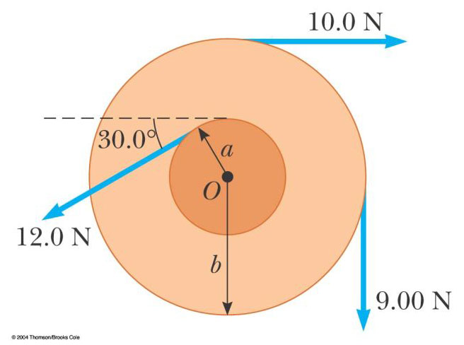

Figure P10.31

32. The tires of a 1 500-kg car are 0.600 m in diameter and the coefficients of friction with the road surface are _{s} = 0.800 and _{k} = 0.600. Assuming that the weight is evenly distributed on the four wheels, calculate the maximum torque that can be exerted by the engine on a driving wheel, without spinning the wheel. If you wish, you may assume the car is at rest.

33. Suppose the car in Problem 32 has a disk brake system. Each wheel is slowed by the friction force between a single brake pad and the disk-shaped rotor. On this particular car, the brake pad contacts the rotor at an average distance of 22.0 cm from the axis. The coefficients of friction between the brake pad and the disk are
_{s} = 0.600 and _{k} = 0.500. Calculate the normal force that the pad must apply to the rotor, in order to slow the car as quickly as possible.

Section 10.7 Relationship between Torque and Angular Acceleration

34. A grinding wheel is in the form of a uniform solid disk of radius 7.00 cm and mass 2.00 kg. It starts from rest and accelerates uniformly under the action of the constant torque of 0.600 N·m that the motor exerts on the wheel. (a) How long does the wheel take to reach its final operating speed of 1 200 rev/min? (b) Through how many revolutions does it turn while accelerating?

35. A model airplane with mass 0.750 kg is tethered by a wire so that it flies in a circle 30.0 m in radius. The airplane engine provides a net thrust of 0.800 N perpendicular to the tethering wire. (a) Find the torque the net thrust produces about the center of the circle. (b) Find the angular acceleration of the airplane when it is in level flight. (c) Find the linear acceleration of the airplane tangent to its flight path.

36. The combination of an applied force and a friction force produces a constant total torque of 36.0 N·m on a wheel rotating about a fixed axis. The applied force acts for 6.00 s. During this time the angular speed of the wheel increases from 0 to 10.0 rad/s. The applied force is then removed, and the wheel comes to rest in 60.0 s. Find (a) the moment of inertia of the wheel, (b) the magnitude of the frictional torque, and (c) the total number of revolutions of the wheel.

37. A block of mass m₁ = 2.00 kg and a block of mass m₂ = 6.00 kg are connected by a massless string over a pulley in the shape of a solid disk having radius R = 0.250 m and mass M = 10.0 kg. These blocks are allowed to move on a fixed block-wedge of angle = 30.0° as in Figure P10.37. The coefficient of kinetic friction is 0.360 for both blocks. Draw free-body diagrams of both blocks and of the pulley. Determine (a) the acceleration of the two blocks, and (b) the tensions in the string on both sides of the pulley.

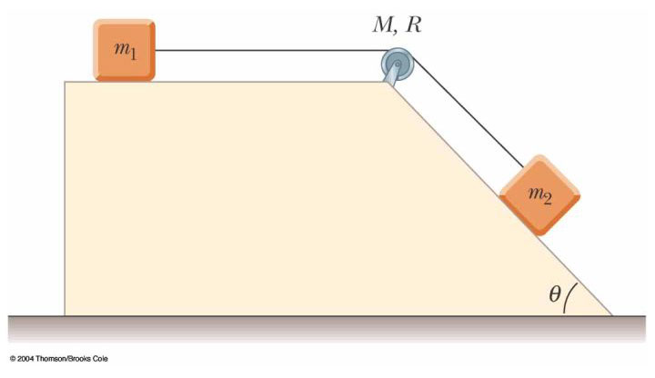

Figure P10.37

38. A potter's wheel—a thick stone disk of radius 0.500 m and mass 100 kg—is freely rotating at 50.0 rev/min. The potter can stop the wheel in 6.00 s by pressing a wet rag against the rim and exerting a radially inward force of 70.0 N. Find the effective coefficient of kinetic friction between wheel and rag.

39. An electric motor turns a flywheel through a drive belt that joins a pulley on the motor and a pulley that is rigidly attached to the flywheel, as shown in Figure P10.39. The flywheel is a solid disk with a mass of 80.0 kg and a diameter of 1.25 m. It turns on a frictionless axle. Its pulley has much smaller mass and a radius of 0.230 m. If the tension in the upper (taut) segment of the belt is 135 N and the flywheel has a clockwise angular acceleration of 1.67 rad/s², find the tension in the lower (slack) segment of the belt.

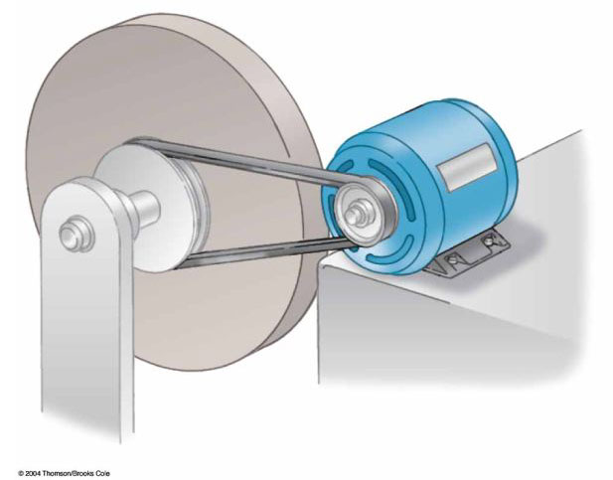

Figure P10.39

Section 10.8 Work, Power, and Energy in Rotational Motion

40. Big Ben, the Parliament tower clock in London, has an hour hand 2.70 m long with a mass of 60.0 kg, and a minute hand 4.50 m long with a mass of 100 kg. Calculate the total rotational kinetic energy of the two hands about the axis of rotation. (You may model the hands as long thin rods.)

41. In a city with an air-pollution problem, a bus has no combustion engine. It runs on energy drawn from a large, rapidly rotating flywheel under the floor of the bus. The flywheel is spun up to its maximum rotation rate of 4 000 rev/min by an electric motor at the bus terminal. Every time the bus speeds up, the flywheel slows down slightly. The bus is equipped with regenerative braking, so that the flywheel can speed up when the bus slows down. The flywheel is a uniform solid cylinder with mass 1 600 kg and radius 0.650 m. The bus body does work against air resistance and rolling resistance at the average rate of 18.0 hp as it travels with an average speed of 40.0 km/h. How far can the bus travel before the flywheel has to be spun up to speed again?

42. The top in Figure P10.42 has a moment of inertia of 4.00 × 10^{–4} kg·m² and is initially at rest. It is free to rotate about the stationary axis AA'. A string, wrapped around a peg along the axis of the top, is pulled in such a manner as to maintain a constant tension of 5.57 N. If the string does not slip while it is unwound from the peg, what is the angular speed of the top after 80.0 cm of string has been pulled off the peg?

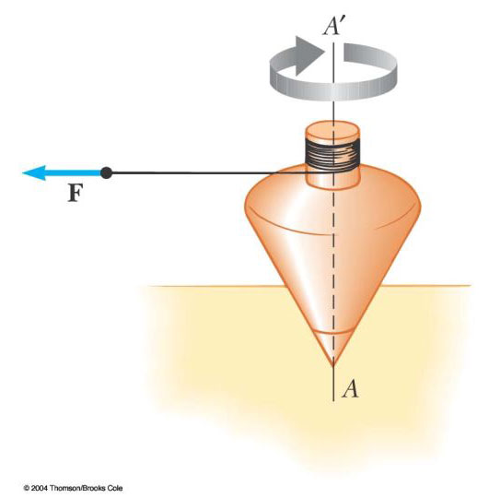

Figure P10.42

43. In Figure P10.43 the sliding block has a mass of 0.850 kg, the counterweight has a mass of 0.420 kg, and the pulley is a hollow cylinder with a mass of 0.350 kg, an inner radius of 0.020 0 m, and an outer radius of 0.030 0 m. The coefficient of kinetic friction between the block and the horizontal surface is 0.250. The pulley turns without friction on its axle. The light cord does not stretch and does not slip on the pulley. The block has a velocity of 0.820 m/s toward the pulley when it passes through a photogate. (a) Use energy methods to predict its speed after it has moved to a second photogate, 0.700 m away. (b) Find the angular speed of the pulley at the same moment.

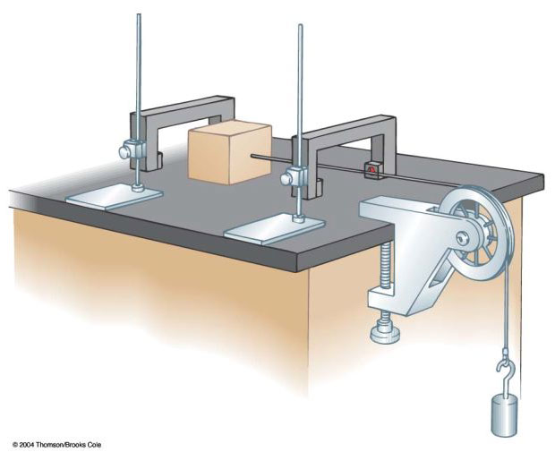

Figure P10.43

44. A cylindrical rod 24.0 cm long with mass 1.20 kg and radius 1.50 cm has a ball of diameter 8.00 cm and mass 2.00 kg attached to one end. The arrangement is originally vertical and stationary, with the ball at the top. The system is free to pivot about the bottom end of the rod after being given a slight nudge. (a) After rotates through ninety degrees, what is its rotational kinetic energy? (b) What is the angular speed of the rod and ball? (c) What is the linear speed of the ball? (d) How does this compare to the speed if the ball had fallen freely through the same distance of 28 cm?

45. An object with a weight of 50.0 N is attached to the free end of a light string wrapped around a reel of radius 0.250 m and mass 3.00 kg. The reel is a solid disk, free to rotate in a vertical plane about the horizontal axis passing through its center. The suspended object is released 6.00 m above the floor. (a) Determine the tension in the string, the acceleration of the object, and the speed with which the object hits the floor. (b) Verify your last answer by using the principle of conservation of energy to find the speed with which the object hits the floor.

46. A 15.0-kg object and a 10.0-kg object are suspended, joined by a cord that passes over a pulley with a radius of 10.0 cm and a mass of 3.00 kg (Fig. P10.46). The cord has a negligible mass and does not slip on the pulley. The pulley rotates on its axis without friction. The objects start from rest 3.00 m apart. Treat the pulley as a uniform disk, and determine the speeds of the two objects as they pass each other.

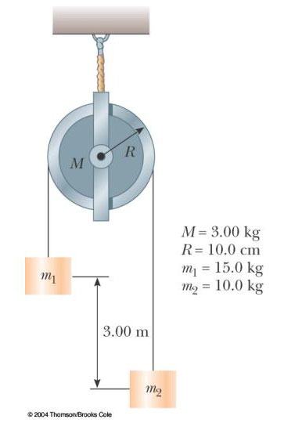

Figure P10.46

47. This problem describes one experimental method for determining the moment of inertia of an irregularly shaped object such as the payload for a satellite. Figure P10.47 shows a counterweight of mass m suspended by a cord wound around a spool of radius r, forming part of a turntable supporting the object. The turntable can rotate without friction. When the counterweight is released from rest, it descends through a distance h, acquiring a speed v. Show that the moment of inertia I of the rotating apparatus (including the turntable) is mr²(2gh/v² – 1).

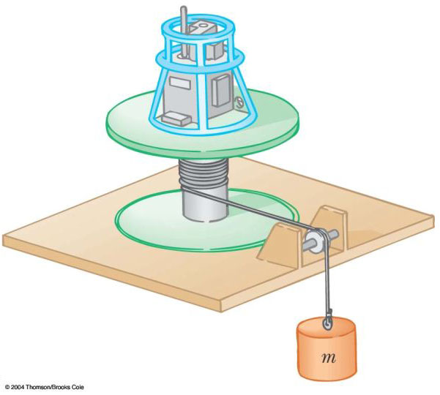

Figure P10.47

48. A horizontal 800-N merry-go-round is a solid disk of radius 1.50 m, started from rest by a constant horizontal force of 50.0 N applied tangentially to the edge of the disk. Find the kinetic energy of the solid disk after 3.00 s.

49. (a) A uniform solid disk of radius R and mass M is free to rotate on a frictionless pivot through a point on its rim (Fig. P10.49). If the disk is released from rest in the position shown by the blue circle, what is the speed of its center of mass when the disk reaches the position indicated by the dashed circle? (b) What is the speed of the lowest point on the disk in the dashed position? (c) What If? Repeat part (a) using a uniform hoop.

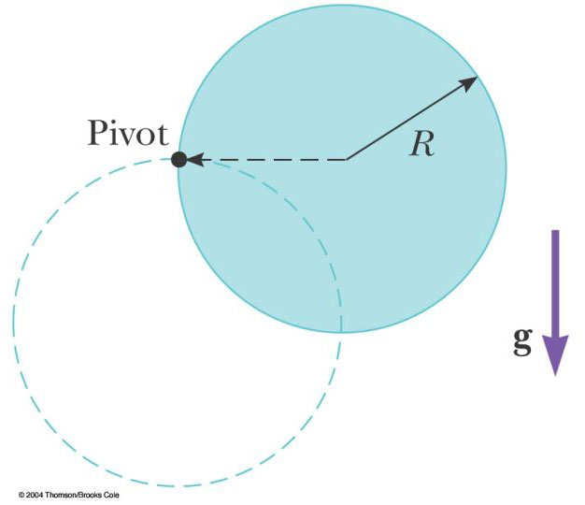

Figure P10.49

50. The head of a grass string trimmer has 100 g of cord wound in a light cylindrical spool with inside diameter
3.00 cm and outside diameter 18.0 cm, as in Figure P10.50. The cord has a linear density of 10.0 g/m. A single strand of the cord extends 16.0 cm from the outer edge of the spool. (a) When switched on, the trimmer speeds up from 0 to 2 500 rev/min in
0.215 s. (a) What average power is delivered to the head by the trimmer motor while it is accelerating? (b) When the trimmer is cutting grass, it spins at
2 000 rev/min and the grass exerts an average tangential force of 7.65 N on the outer end of the cord, which is still at a radial distance of 16.0 cm from the outer edge of the spool. What is the power delivered to the head under load?

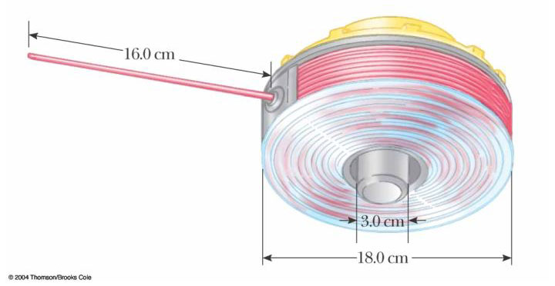

Figure P10.50

Section 10.9 Rolling Motion of a Rigid Object

51. A cylinder of mass 10.0 kg rolls without slipping on a horizontal surface. At the instant its center of mass has a speed of 10.0 m/s, determine (a) the translational kinetic energy of its center of mass, (b) the rotational kinetic energy about its center of mass; and (c) its total energy.

52. A bowling ball has a mass M, radius R, and a moment of inertia of 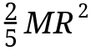. If it starts from rest, how much work must be done on it to set it rolling without slipping at a linear speed v? Express the work in terms of M and v.

53. (a) Determine the acceleration of the center of mass of a uniform solid disk rolling down an incline making angle with the horizontal. Compare this acceleration with that of a uniform hoop. (b) What is the minimum coefficient of friction required to maintain pure rolling motion for the disk?

54. A uniform solid disk and a uniform hoop are placed side by side at the top of an incline of height h. If they are released from rest and roll without slipping, which object reaches the bottom first? Verify your answer by calculating their speeds when they reach the bottom in terms of h.

55. A metal can containing condensed mushroom soup has mass 215 g, height 10.8 cm and diameter 6.38 cm. It is placed at rest on its side at the top of a 3.00-m long incline that is at 25.0° to the horizontal, and is then released to roll straight down. Assuming mechanical energy conservation, calculate the moment of inertia of the can if it takes 1.50 s to reach the bottom of the incline. Which pieces of data, if any, are unnecessary for calculating the solution?

56. A tennis ball is a hollow sphere with a thin wall. It is set rolling without slipping at 4.03 m/s on a horizontal section of a track, as shown in Figure P10.56. It rolls around the inside of a vertical circular loop 90.0 cm in diameter, and finally leaves the track at a point 20.0 cm below the horizontal section. (a) Find the speed of the ball at the top of the loop. Demonstrate that it will not fall from the track. (b) Find its speed as it leaves the track. (c) Suppose that static friction between ball and track were negligible, so that the ball slid instead of rolling. Would its speed then be higher, lower, or the same at the top of the loop? Explain.

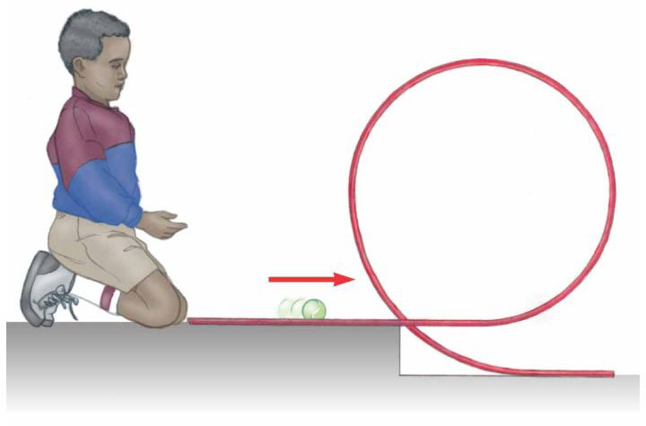

Figure P10.56

Additional Problems

57. Toppling chimneys often break apart in mid-fall because the mortar between the bricks cannot withstand much shear stress. As the chimney begins to fall, shear forces must act on the topmost sections to accelerate them tangentially so that they can keep up with the rotation of the lower part of the stack. For simplicity, let us model the chimney as a uniform rod of length pivoted at the lower end. The rod starts at rest in a vertical position (with the frictionless pivot at the bottom) and falls over under the influence of gravity. What fraction of the length of the rod has a tangential acceleration greater than gsin, where is the angle the chimney makes with the vertical axis?

58. Review problem. A mixing beater consists of three thin rods, each 10.0 cm long. The rods diverge from a central hub, separated from each other by 120°, and all turn in the same plane. A ball is attached to the end of each rod. Each ball has cross-sectional area 4.00 cm² and is so shaped that it has a drag coefficient of 0.600. Calculate the power input required to spin the beater at 1 000 rev/min (a) in air and (b) in water.

59. A 4.00-m length of light nylon cord is wound around a uniform cylindrical spool of radius 0.500 m and mass 1.00 kg. The spool is mounted on a frictionless axle and is initially at rest. The cord is pulled from the spool with a constant acceleration of magnitude 2.50 m/s². (a) How much work has been done on the spool when it reaches an angular speed of 8.00 rad/s? (b) Assuming there is enough cord on the spool, how long does it take the spool to reach this angular speed? (c) Is there enough cord on the spool?

60. A videotape cassette contains two spools, each of radius r_{s}, on which the tape is wound. As the tape unwinds from the first spool, it winds around the second spool. The tape moves at constant linear speed v past the heads between the spools. When all the tape is on the first spool, the tape has an outer radius r_{t}. Let r represent the outer radius of the tape on the first spool at any instant while the tape is being played. (a) Show that at any instant the angular speeds of the two spools are

₁ = v/r and ₂ = v/( r_{s}² + r_{t}² – r² )^{1/2}

(b) Show that these expressions predict the correct maximum and minimum values for the angular speeds of the two spools.

61. A long uniform rod of length L and mass M is pivoted about a horizontal, frictionless pin through one end. The rod is released from rest in a vertical position, as shown in Figure P10.61. At the instant the rod is horizontal, find (a) its angular speed, (b) the magnitude of its angular acceleration, (c) the x and y components of the acceleration of its center of mass, and (d) the components of the reaction force at the pivot.

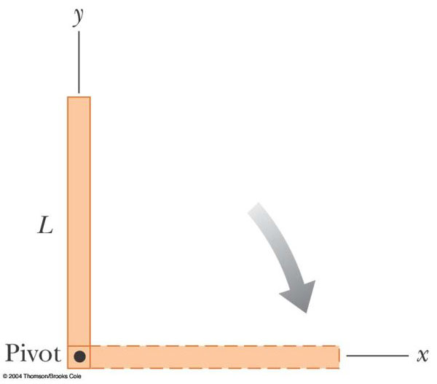

Figure P10.61

62. A shaft is turning at 65.0 rad/s at time t = 0. Thereafter, its angular acceleration is given by
= –10.0 rad/s² – 5.00t rad/s³,

where t is the elapsed time. (a) Find its angular speed at t = 3.00 s. (b) How far does it turn in these 3 s?

63. A bicycle is turned upside down while its owner repairs a flat tire. A friend spins the other wheel, of radius 0.381 m, and observes that drops of water fly off tangentially. She measures the height reached by drops moving vertically (Fig. P10.63). A drop that breaks loose from the tire on one turn rises h = 54.0 cm above the tangent point. A drop that breaks loose on the next turn rises 51.0 cm above the tangent point. The height to which the drops rise decreases because the angular speed of the wheel decreases. From this information, determine the magnitude of the average angular acceleration of the wheel.

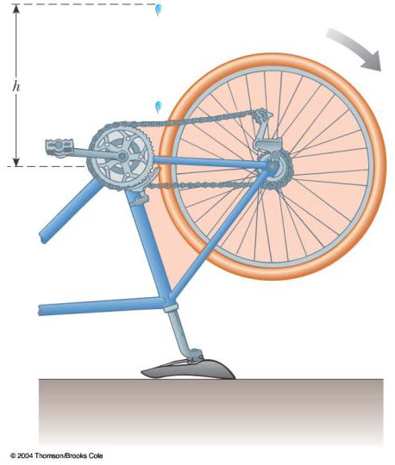

Figure P10.63 Problems 63 and 64.

64. A bicycle is turned upside down while its owner repairs a flat tire. A friend spins the other wheel of radius R and observes that drops of water fly off tangentially. She measures the height reached by drops moving vertically (Fig. P10.63). A drop that breaks loose from the tire on one turn rises a distance h₁ above the tangent point. A drop that breaks loose on the next turn rises a distance h₂ < h₁ above the tangent point. The height to which the drops rise decreases because the angular speed of the wheel decreases. From this information, determine the magnitude of the average angular acceleration of the wheel.

65. A cord is wrapped around a pulley of mass m and radius r. The free end of the cord is connected to a block of mass M. The block starts from rest and then slides down an incline that makes an angle with the horizontal. The coefficient of kinetic friction between block and incline is. (a) Use energy methods to show that the block's speed as a function of position d down the incline is

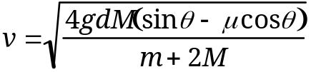

(b) Find the magnitude of the acceleration of the block in terms of , m, M, g, and .

66. (a) What is the rotational kinetic energy of the Earth about its spin axis? Model the Earth as a uniform sphere and use data from the endpapers. (b) The rotational kinetic energy of the Earth is decreasing steadily because of tidal friction. Find the change in one day, assuming that the rotational period decreases by 10.0 s each year.

67. Due to a gravitational torque exerted by the Moon on the Earth, our planet’s rotation period slows at a rate on the order of 1 ms/century. (a) Determine the order of magnitude of the Earth’s angular acceleration. (b) Find the order of magnitude of the torque. (c) Find the order of magnitude of the size of the wrench an ordinary person would need to exert such a torque, as in Figure P10.67. Assume the person can brace his feet against a solid firmament.

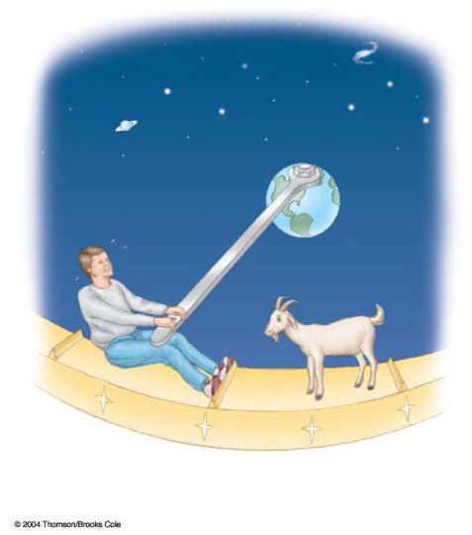

Figure P10.67

68. The speed of a moving bullet can be determined by allowing the bullet to pass through two rotating paper disks mounted a distance d apart on the same axle (Fig. P10.68). From the angular displacement of the two bullet holes in the disks and the rotational speed of the disks, we can determine the speed v of the bullet. Find the bullet speed for the following data:
d = 80 cm, = 900 rev/min, and = 31.0°.

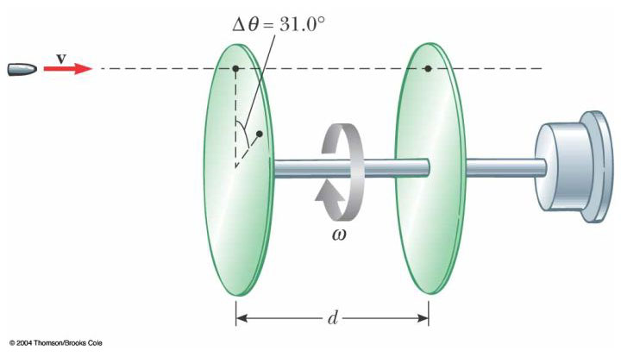

Figure P10.68

69. A uniform, hollow, cylindrical spool has inside radius R/2, outside radius R, and mass M (Fig. P10.69). It is mounted so that it rotates on a fixed horizontal axle. A counterweight of mass m is connected to the end of a string wound around the spool. The counterweight falls from rest at t = 0 to a position y at time t. Show that the torque due to the friction forces between spool and axle is

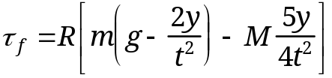

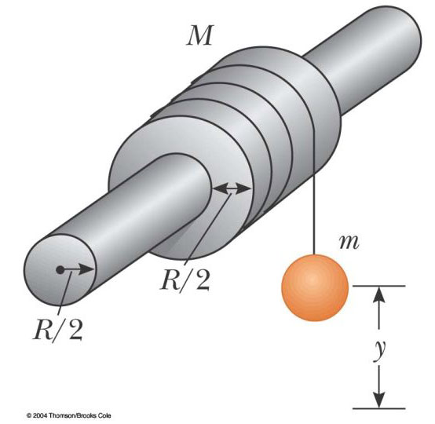

Figure P10.69

70. The reel shown in Figure P10.70 has radius R and moment of inertia I. One end of the block of mass m is connected to a spring of force constant k, and the other end is fastened to a cord wrapped around the reel. The reel axle and the incline are frictionless. The reel is wound counterclockwise so that the spring stretches a distance d from its unstretched position and is then released from rest. (a) Find the angular speed of the reel when the spring is again unstretched. (b) Evaluate the angular speed numerically at this point if I = 1.00 kg·m², R = 0.300 m, k = 50.0 N/m, m = 0.500 kg, d = 0.200 m, and = 37.0°.

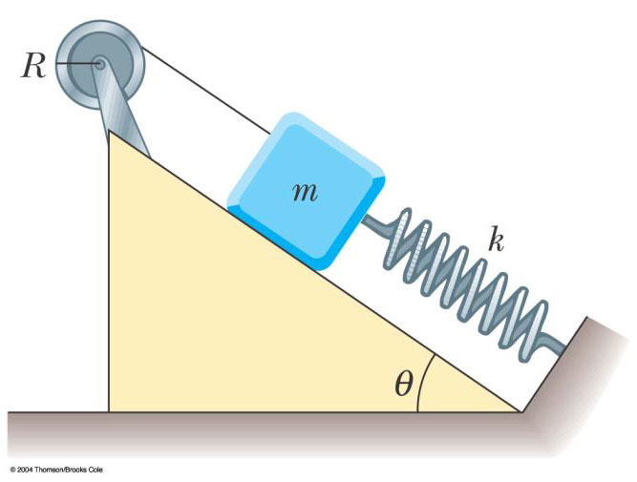

Figure P10.70

71. Two blocks, as shown in Figure P10.71, are connected by a string of negligible mass passing over a pulley of radius 0.250 m and moment of inertia I. The block on the frictionless incline is moving up with a constant acceleration of 2.00 m/s². (a) Determine T₁ and T₂, the tensions in the two parts of the string. (b) Find the moment of inertia of the pulley.

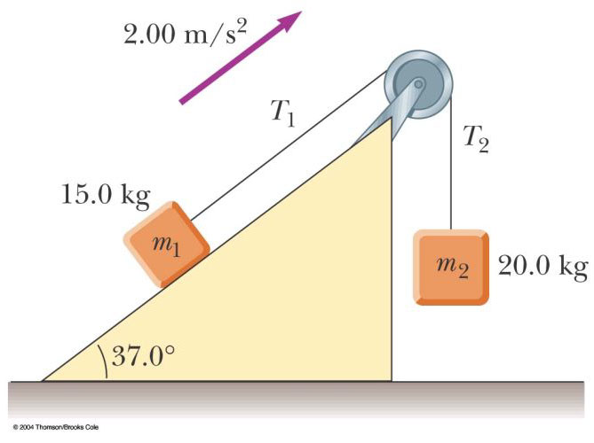

Figure P10.71

72. A common demonstration, illustrated in Figure P10.72, consists of a ball resting at one end of a uniform board of length , hinged at the other end, and elevated at an angle . A light cup is attached to the board at r_{c} so that it will catch the ball when the support stick is suddenly removed. (a) Show that the ball will lag behind the falling board when is less than 35.3°. (b) If the board is 1.00 m long and is supported at this limiting angle, show that the cup must be 18.4 cm from the moving end.

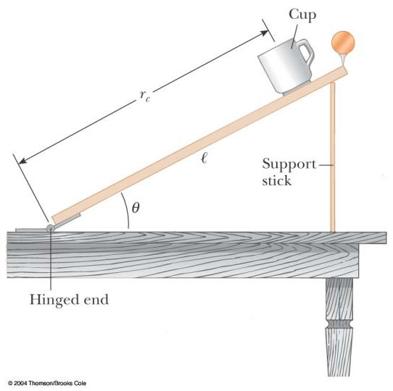

Figure P10.72

73. As a result of friction, the angular speed of a wheel changes with time according to

d/dt = 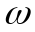₀e^{–σ t}

where ₀ and are constants. The angular speed changes from 3.50 rad/s at t = 0 to 2.00 rad/s at t = 9.30 s. Use this information to determine and ₀. Then determine (a) the magnitude of the angular acceleration at t = 3.00 s, (b) the number of revolutions the wheel makes in the first 2.50 s, and (c) the number of revolutions it makes before coming to rest.

74. The hour hand and the minute hand of Big Ben, the Parliament tower clock in London, are 2.70 m and 4.50 m long and have masses of 60.0 kg and 100 kg, respectively. (a) Determine the total torque due to the weight of these hands about the axis of rotation when the time reads (i) 3:00, (ii) 5:15, (iii) 6:00, (iv) 8:20, (v) 9:45. (You may model the hands as long thin uniform rods.) (b) Determine all times when the total torque about the axis of rotation is zero. Determine the times to the nearest second, solving a transcendental equation numerically.

75. (a) Without the wheels, a bicycle frame has a mass of 8.44 kg. Each of the wheels can be roughly modeled as a uniform solid disk with a mass of 0.820 kg and a radius of 0.343 m. Find the kinetic energy of the whole bicycle when it is moving forward at 3.35 m/s. (b) Before the invention of a wheel turning on an axle, ancient people moved heavy loads by placing rollers under them. (Modern people use rollers too. Any hardware store will sell you a roller bearing for a lazy susan.) A stone block of mass 844 kg moves forward at 0.335 m/s, supported by two uniform cylindrical tree trunks, each of mass 82.0 kg and radius 0.343 m. No slipping occurs between the block and the rollers or between the rollers and the ground. Find the total kinetic energy of the moving objects.

76. A uniform solid sphere of radius r is placed on the inside surface of a hemispherical bowl with much larger radius R. The sphere is released from rest at an angle to the vertical and rolls without slipping (Fig. P10.76). Determine the angular speed of the sphere when it reaches the bottom of the bowl.

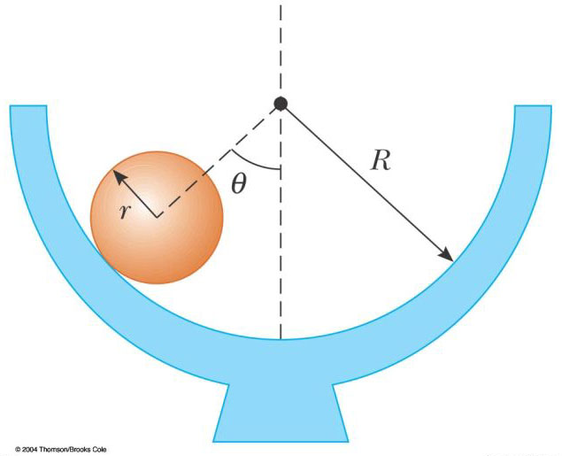

Figure P10.76

77. A string is wound around a uniform disk of radius R and mass M. The disk is released from rest with the string vertical and its top end tied to a fixed bar (Fig. P10.77). Show that (a) the tension in the string is one-third the weight of the disk, (b) the magnitude of the acceleration of the center of mass is 2g/3, and (c) the speed of the center of mass is (4gh/3)^{1/2} after the disk has descended through distance h. Verify your answer to (c) using the energy approach.

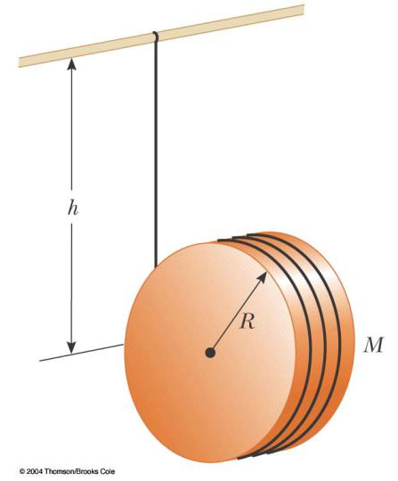

Figure P10.77

78. A constant horizontal force F is applied to a lawn roller in the form of a uniform solid cylinder of radius R and mass M (Fig. P10.78). If the roller rolls without slipping on the horizontal surface, show that (a) the acceleration of the center of mass is 2F/3M and (b) the minimum coefficient of friction necessary to prevent slipping is F/3Mg. (Hint: Take the torque with respect to the center of mass.)

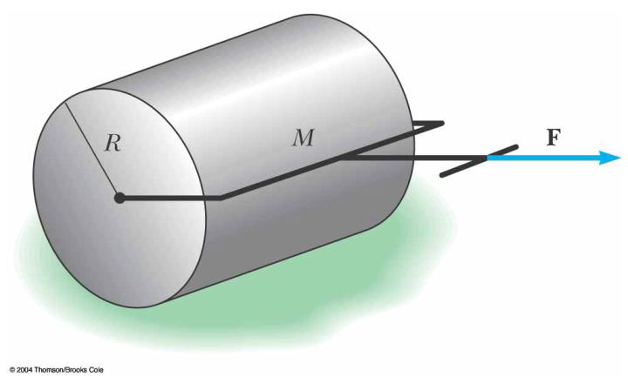

Figure P10.78

79. A solid sphere of mass m and radius r rolls without slipping along the track shown in Figure P10.79. It starts from rest with the lowest point of the sphere at height h above the bottom of the loop of radius R, much larger than r. (a) What is the minimum value of h (in terms of R) such that the sphere completes the loop? (b) What are the force components on the sphere at the point P if h = 3R?

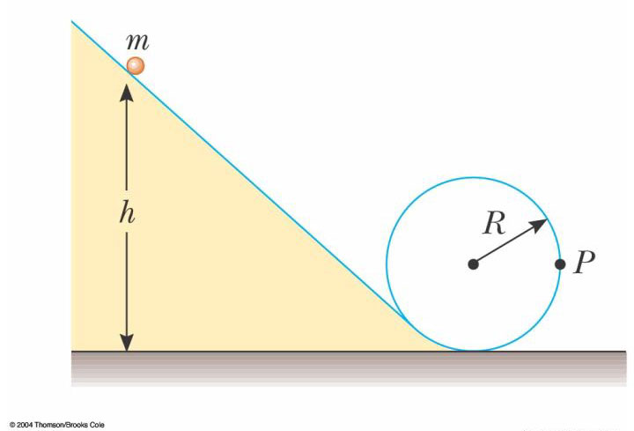

Figure P10.79

80. A thin rod of mass 0.630 kg and length 1.24 m is at rest, hanging vertically from a strong fixed hinge at its top end. Suddenly a horizontal impulsive force 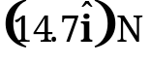 is applied to it. (a) Suppose the force acts at the bottom end of the rod. Find the acceleration of its center of mass and the horizontal force the hinge exerts. (b) Suppose the force acts at the midpoint of the rod. Find the acceleration of this point and the horizontal hinge reaction. (c) Where can the impulse be applied so that the hinge will exert no horizontal force? This point is called the center of percussion.

81. A bowler releases a bowling ball with no spin, sending it sliding straight down the alley toward the pins. The ball continues to slide for a distance of what order of magnitude, before its motion becomes rolling without slipping? State the quantities you take as data, the values you measure or estimate for them, and your reasoning.

82. Following Thanksgiving dinner your uncle falls into a deep sleep, sitting straight up facing the television set. A naughty grandchild balances a small spherical grape at the top of his bald head, which itself has the shape of a sphere. After all the children have had time to giggle, the grape starts from rest and rolls down without slipping. It will leave contact with your uncle’s scalp when the radial line joining it to the center of curvature makes what angle with the vertical?

83. (a) A thin rod of length h and mass M is held vertically with its lower end resting on a frictionless horizontal surface. The rod is then released to fall freely. Determine the speed of its center of mass just before it hits the horizontal surface. (b) What If? Now suppose the rod has a fixed pivot at its lower end. Determine the speed of the rod's center of mass just before it hits the surface.

84. A large, cylindrical roll of tissue paper of initial radius R lies on a long, horizontal surface with the outside end of the paper nailed to the surface. The roll is given a slight shove (v_{i} 0) and commences to unroll. Assume the roll has a uniform density and that mechanical energy is conserved in the process. (a) Determine the speed of the center of mass of the roll when its radius has diminished to r. (b) Calculate a numerical value for this speed at r = 1.00 mm, assuming R = 6.00 m. (c) What If? What happens to the energy of the system when the paper is completely unrolled?

85. A spool of wire of mass M and radius R is unwound under a constant force F (Fig. P10.85). Assuming the spool is a uniform solid cylinder that doesn't slip, show that (a) the acceleration of the center of mass is 4F/3M and (b) the force of friction is to the right and equal in magnitude to F/3. (c) If the cylinder starts from rest and rolls without slipping, what is the speed of its center of mass after it has rolled through a distance d?

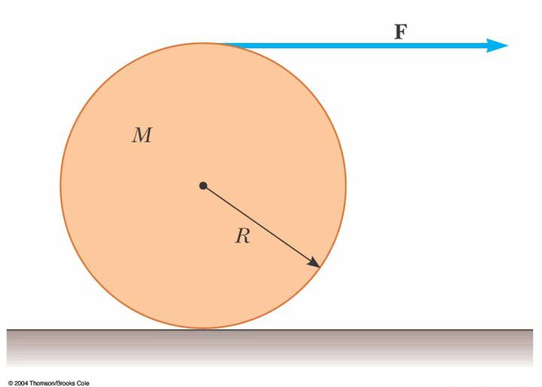

Figure P10.85

86. A plank with a mass M = 6.00 kg rides on top of two identical solid cylindrical rollers that have R = 5.00 cm and m = 2.00 kg (Fig. P10.86). The plank is pulled by a constant horizontal force F of magnitude 6.00 N applied to the end of the plank and perpendicular to the axes of the cylinders (which are parallel). The cylinders roll without slipping on a flat surface. There is also no slipping between the cylinders and the plank. (a) Find the acceleration of the plank and of the rollers. (b) What friction forces are acting?

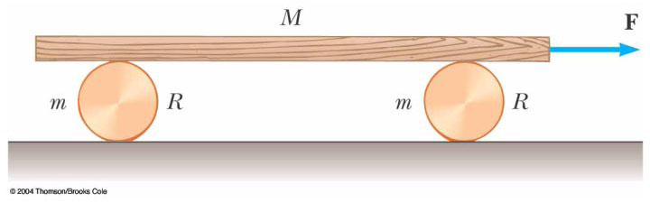

Figure P10.86

87. A spool of wire rests on a horizontal surface as in Figure P10.87. As the wire is pulled, the spool does not slip at the contact point P. On separate trials, each one of the forces F₁, F₂, F₃, and F₄ is applied to the spool. For each one of these forces, determine the direction the spool will roll. Note that the line of action of F₂ passes through P.

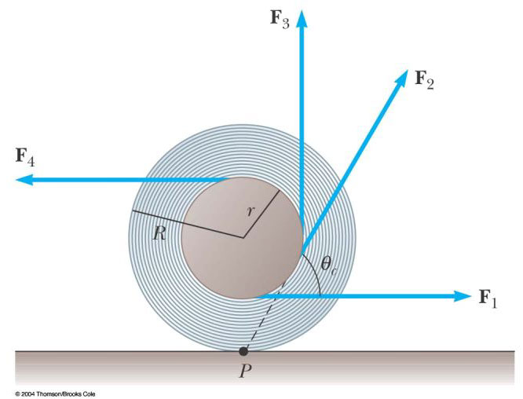

Figure P10.87

88. Refer to Problem 87 and Figure P10.87. The spool of wire has an inner radius r and an outer radius R. The angle between the applied force and the horizontal can be varied. Show that the critical angle for which the spool does not roll is given by

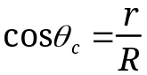

If the wire is held at this angle and the force increased, the spool will remain stationary until it slips along the floor.

89. In a demonstration known as the ballistics cart, a ball is projected vertically upward from a cart moving with constant velocity along the horizontal direction. The ball lands in the catching cup of the cart because both the cart and ball have the same horizontal component of velocity. What If? Now consider a ballistics cart on an incline making an angle with the horizontal as in Figure P10.89. The cart (including wheels) has a mass M and the moment of inertia of each of the two wheels is mR²/2. (a) Using conservation of energy (assuming no friction between cart and axles), and assuming pure rolling motion (no slipping), show that the acceleration of the cart along the incline is

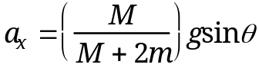

(b) Note that the x component of acceleration of the ball released by the cart is g sin . Thus, the x component of the cart's acceleration is smaller than that of the ball by the factor M/(M + 2m). Use this fact and kinematic equations to show that the ball overshoots the cart by an amount x, where

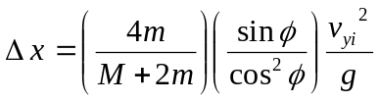

and v_{yi} is the initial speed of the ball imparted to it by the spring in the cart.
(c) Show that the distance d that the ball travels measured along the incline is

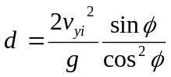

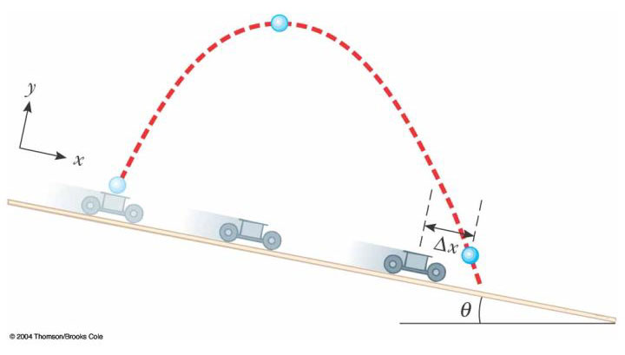

Figure P10.89

90. A spool of thread consists of a cylinder of radius R₁ with end caps of radius R₂ as in the end view shown in Figure P10.90. The mass of the spool, including the thread, is m and its moment of inertia about an axis through its center is I. The spool is placed on a rough horizontal surface so that it rolls without slipping when a force T acting to the right is applied to the free end of the thread. Show that the magnitude of the frictional force exerted by the surface on the spool is given by

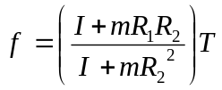

Determine the direction of the force of friction.

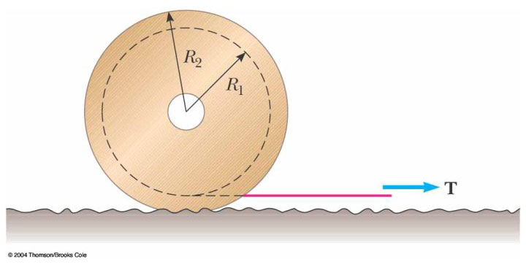

Figure P10.90

© Copyright 2004 Thomson. All rights reserved.

